***NAME : Himanshu Dixit***

***ENROLL NO. : 21103262***

***BATCH : B11***

***Data Structure Lab – II [15B17CI271]***

***Lab A Week 8***

***Solution 1)***

*#include<bits/stdc++.h> usingnamespacestd;*

*intmain()*

*{*

*inta[10],count=0; for(inti=0;i<10;i++)*

*{*

*a[i]=-1;*

*}*

*cout<<"enterthekeyvaluetobeinserted:(enter-1tostop):"; while(1)*

*{*

*intb; cin>>b;*

*if(b!=-1)*

*{*

*count++; intf=0; intc=b%9; intj=0;*

*do*

*{*

*if(a[c]==-1)*

*{*

*a[c]=b; f=1;*

*}*

*else*

*{*

*c=(b+j)%9; j++;*

*}*

*}while(f==0);*

*}*

*else*

*break;*

*if(count==10)*

*break;*

*}*

*cout<<"hashtable:"<<endl; for(inti=0;i<10;i++)*

*{*

*if(a[i]!=-1)*

*{*

*cout<<i<<":"<<a[i]<<endl;;*

*}*

*else*

*{*

*cout<<i<<":"<<"empty"<<endl;*

*}*

*}*

*}*

***Output:***

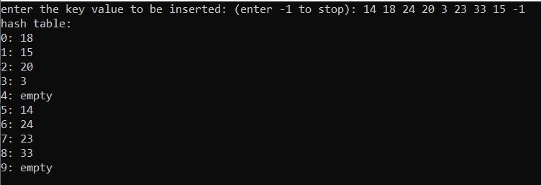

***Solution 2)***

*#include<bits/stdc++.h> usingnamespacestd;*

*intmain()*

*{*

*inta[11],count=0; for(inti=0;i<11;i++)*

*{*

*a[i]=-1;*

*}*

*cout<<"enterthekeyvaluetobeinserted:(enter-1tostop):"; while(1)*

*{*

*intb; cin>>b;*

*if(b!=-1)*

*{*

*count++; intf=0; intc=b%7; intj=0;*

*do*

*{*

*if(a[c]==-1)*

*{*

*a[c]=b; f=1;*

*}*

*else*

*{*

*c=(b+j)%11; j++;*

*}*

*}while(f==0);*

*}*

*else*

*break;*

*if(count==11)*

*break;*

*}*

*cout<<"hashtable:"<<endl; for(inti=0;i<11;i++)*

*{*

*if(a[i]!=-1)*

*{*

*cout<<i<<":"<<a[i]<<endl;;*

*}*

*else*

*{*

*cout<<i<<":"<<"empty"<<endl;*

*}*

*}*

*}*

***Output:***

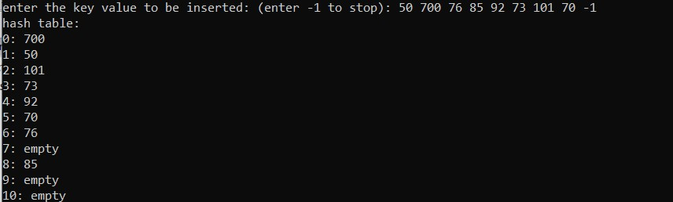

***Solution 3)***

*#include<bits/stdc++.h> usingnamespacestd; structnode*

*{*

*intdata; node*next; };*

*intmain()*

*{*

*cout<<"enternoofbuckets:";*

*intn; cin>>n; node*a=newnode[n];*

*for(inti=0;i<n;i++)*

*{*

*a[i].data=i; a[i].next=NULL;*

*}*

*cout<<"enterthekeyvaluetobeinserted:(enter-1tostop):"; while(1)*

*{*

*intb; cin>>b;*

*if(b!=-1)*

*{*

*intc=b%n; node*p=newnode; p->data=b; p->next=NULL; if(a[c].next==NULL)*

*{*

*a[c].next=p;*

*}*

*else*

*{*

*p->next=a[c].next; a[c].next=p;*

*}*

*}*

*else break;*

*}*

*cout<<"hashtable:"<<endl; for(inti=0;i<n;i++)*

*{*

*if(a[i].next!=NULL)*

*{*

*cout<<i<<":"; node*p=a[i].next; while(p!=NULL)*

*{*

*cout<<p->data<<"->"; p=p->next;*

*}*

*cout<<endl;*

*}*

*}*

*}*

***Output:***

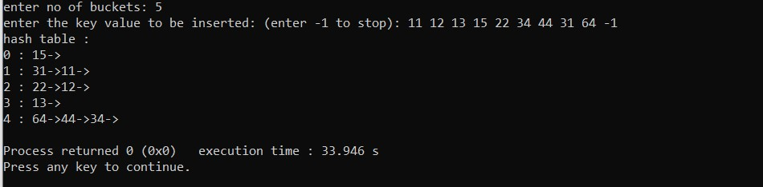

***Solution 4)***

***Q1)***

***Using quadratic probing***

*#include<bits/stdc++.h> usingnamespacestd;*

*intmain()*

*{*

*inta[10],count=0; for(inti=0;i<10;i++)*

*{*

*a[i]=-1;*

*}*

*cout<<"enterthekeyvaluetobeinserted:(enter-1tostop):"; while(1)*

*{*

*intb; cin>>b;*

*if(b!=-1)*

*{*

*count++; intf=0; intc=b%9; intj=0;*

*do {*

*if(a[c]==-1)*

*{*

*a[c]=b; f=1;*

*}*

*else*

*{*

*c=(b+(j*j))%9; j++;*

*}*

*}while(f==0);*

*}*

*else*

*break;*

*if(count==10)*

*break;*

*}*

*cout<<"hashtable:"<<endl; for(inti=0;i<10;i++)*

*{*

*if(a[i]!=-1)*

*{*

*cout<<i<<":"<<a[i]<<endl;;*

*}*

*else*

*{*

*cout<<i<<":"<<"empty"<<endl;*

*}*

*}*

*}*

***Output:***

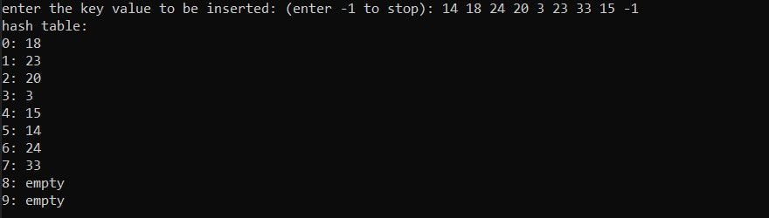

***Q2)***

***With quadratic probing***

*#include<bits/stdc++.h> usingnamespacestd;*

*intmain()*

*{*

*inta[11],count=0; for(inti=0;i<11;i++)*

*{*

*a[i]=-1;*

*}*

*cout<<"enterthekeyvaluetobeinserted:(enter-1tostop):"; while(1)*

*{*

*intb; cin>>b;*

*if(b!=-1)*

*{*

*count++; intf=0; intc=b%7; intj=0;*

*do*

*{*

*if(a[c]==-1)*

*{*

*a[c]=b; f=1;*

*}*

*else*

*{*

*c=(b+(j*j))%11; j++;*

*}*

*}while(f==0);*

*}*

*else*

*break;*

*if(count==11)*

*break;*

*}*

*cout<<"hashtable:"<<endl; for(inti=0;i<11;i++)*

*{*

*if(a[i]!=-1)*

*{*

*cout<<i<<":"<<a[i]<<endl;;*

*}*

*else*

*{*

*cout<<i<<":"<<"empty"<<endl;*

*}*

*}*

*}*

*Output:*

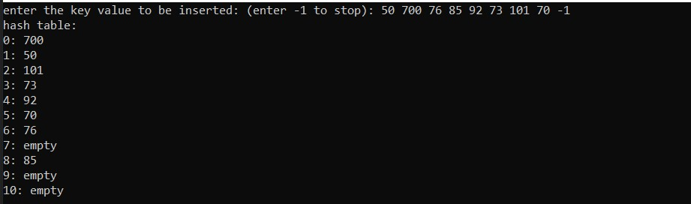

***Solution 5)***

***Q1)***

***With chain hashing:***

*#include<bits/stdc++.h> usingnamespacestd; structnode*

*{*

*intdata; node*next; };*

*intmain()*

*{*

*intn=9; node*a=newnode[n];*

*for(inti=0;i<n;i++)*

*{*

*a[i].data=i; a[i].next=NULL;*

*}*

*cout<<"enterthekeyvaluetobeinserted:(enter-1tostop):"; while(1)*

*{*

*intb; cin>>b;*

*if(b!=-1)*

*{*

*intc=b%n; node*p=newnode; p->data=b; p->next=NULL; if(a[c].next==NULL)*

*{*

*a[c].next=p;*

*}*

*else*

*{*

*p->next=a[c].next; a[c].next=p;*

*}*

*}*

*else break;*

*}*

*cout<<"hashtable:"<<endl; for(inti=0;i<n;i++)*

*{*

*if(a[i].next!=NULL)*

*{*

*cout<<i<<":"; node*p=a[i].next; while(p!=NULL)*

*{*

*cout<<p->data<<"->"; p=p->next;*

*}*

*cout<<endl;*

*}*

*}*

*}*

***Output:***

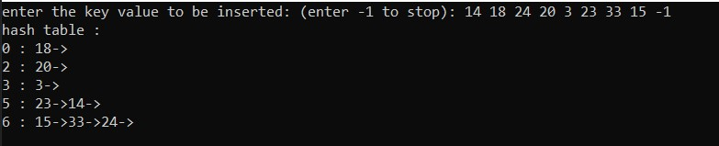

***Q2)***

***With chain hashing***

*#include<bits/stdc++.h> usingnamespacestd; structnode*

*{*

*intdata; node*next; };*

*intmain()*

*{*

*intn=7; node*a=newnode[n];*

*for(inti=0;i<n;i++)*

*{*

*a[i].data=i; a[i].next=NULL;*

*}*

*cout<<"enterthekeyvaluetobeinserted:(enter-1tostop):"; while(1)*

*{*

*intb; cin>>b;*

*if(b!=-1)*

*{*

*intc=b%n; node*p=newnode; p->data=b; p->next=NULL; if(a[c].next==NULL)*

*{*

*a[c].next=p;*

*}*

*else*

*{*

*p->next=a[c].next; a[c].next=p;*

*}*

*}*

*else break;*

*}*

*cout<<"hashtable:"<<endl; for(inti=0;i<n;i++)*

*{*

*if(a[i].next!=NULL)*

*{*

*cout<<i<<":"; node*p=a[i].next; while(p!=NULL)*

*{*

*cout<<p->data<<"->"; p=p->next;*

*}*

*cout<<endl;*

*}*

*}*

*}*

***Output:***

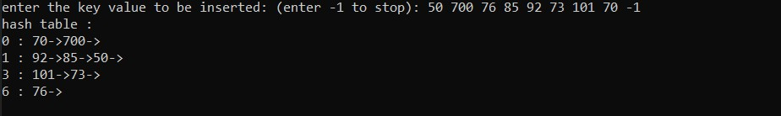

***Solution 6)***

*#include<bits/stdc++.h> usingnamespacestd;*

*intmain()*

*{*

*inta[11],count=0; for(inti=0;i<11;i++)*

*{*

*a[i]=-1;*

*}*

*cout<<"enterthekeyvaluetobeinserted:(enter-1tostop):"; while(1)*

*{*

*intb; cin>>b;*

*if(b!=-1)*

*{*

*count++; intf=0; intc=b%11; intj=0;*

*do {*

*if(a[c]==-1)*

*{*

*a[c]=b; f=1;*

*}*

*else*

*{*

*c=((b%7)+j*(b%3))%11; j++;*

*}*

*}while(f==0);*

*}*

*else*

*break;*

*if(count==10)*

*break;*

*}*

*cout<<"hashtable:"<<endl; for(inti=0;i<10;i++)*

*{*

*if(a[i]!=-1)*

*{*

*cout<<i<<":"<<a[i]<<endl;;*

*}*

*else*

*{*

*cout<<i<<":"<<"empty"<<endl;*

*}*

*}*

*}*

***Output:***

